**FORM 3 BIOLOGY**

**TERM II OPENER EXAMS**

1. ​ ​​ ​a.​ ​​ ​​ ​​ ​​ ​​ ​Define​ ​the​ ​term​ ​respiratory​ ​Quontient​ ​RQ? (1mk)

………………………………………………………………………………………………………………………………………………………………………………………………………………

a. (i).​ ​​ ​A​ ​food​ ​substance​ ​C​54​H​104​O​6​​ ​is​ ​oxidized​ ​completely.​ ​​ ​What​ ​will​ ​be​ ​its ​ ​​ ​​ ​​ ​​ ​​ ​​ ​​ ​​ ​respiratory​ ​Quotient​ ​show​ ​your​ ​working (1mk) ​ ​

C​57​ ​​H​104​ ​​O​6​​ ​+​ ​80​O2​​ ​ ​ 57CO​2​ ​​ ​​ ​​+​ ​​ ​52H​2​O​ ​​+​ ​​38.21g

ii.​ ​​ ​​ ​State​ ​the​ ​type​ ​of​ ​food​ ​being​ ​oxidized. (1mk) Give​ ​a​ ​reason​ ​for​ ​your​ ​answer (1mk)

………………………………………………………………………………………………………

1. (i) The diagram below represents a plant cell.

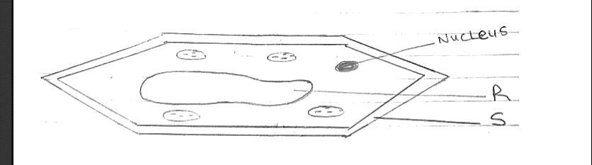

(a) Name a carbohydrate which forms part of the structure labelled S. (1mk)

………………………………………………………………………………………………………

(b) State two functions of the part labelled R (2mks)

………………………………………………………………………………………………………

(c) Name two structures present in the diagram but absent in an animal cell (2mks)

………………………………………………………………………………………………………………………………………………………………………………………………………………

(ii) Name the organelles that perform each of the following functions (3mks)

(a) Excretion in amoeba………………………………………………

(b) Carries out digestion and destruction of worn out cell organelles

…………………………………………………………………………

(c) Movement in paramecium…………………………………………..

1. Why are the following procedures done when preparing sections to be observed under a light microscope? (3mks)

(a) Making of thin sections ………………………………………………………………………………………………………………………………………………………………………………………………………………

(b) Using a sharp blade to make the sections ………………………………………………………………………………………………………………………………………………………………………………………………………………

c)Staining

………………………………………………………………………………………………………………………………………………………………………………………………………………

1. State​ ​the​ ​role​ ​of​ ​the​ ​following​ ​organelles (2mks)

(i)​ ​Lysosomes ………………………………………………………………………………………………………………………………………………………………………………………………………………

(ii)​ ​Mitochondria………………………………………………………………………………………………………………………………………………………………………………………………

1. Suppose​ ​you​ ​are​ ​asked​ ​to​ ​study​ ​population​ ​of​ ​fish​ ​in​ ​a​ ​school​ ​pond.
2. List​ ​down​ ​the​ ​apparatus​ ​you​ ​would​ ​need​ ​for​ ​this​ ​investigation. (2​ ​mks)

………………………………………………………………………………………………………………………………………………………………………………………………………………

1. (i) State​ ​the​ ​method​ ​of​ ​sampling​ ​you​ ​would​ ​use. (1​ ​mk)
2. …………………………………………………………………………………………………

(iii) What precautions should be taken when using method named in (b) (i) above? (2 mks)

………………………………………………………………………………………………………………………………………………………………………………………………………………

………………………………………………………………………………………………………………………………………………………………………………………………………………

1. (i) Work out a mathematical formula you would use to calculate the total population in the​ ​pond. (3​ ​mks)

………………………………………………………………………………………………………………………………………………………………………………………………………………

1. What​ ​assumptions​ ​are​ ​made​ ​when​ ​using​ ​formula​ ​in​ ​(c)​ ​(i)​ ​above? (2 mks)

…………………………………………………………………………………………………………………………………………………………………………………………………………

(d) Explain​ ​how​ ​light​ ​intensity​ ​would​ ​affect​ ​the​ ​distribution​ ​of​ ​fish​ ​in​ ​this​ ​pond. (4 ​mks)

………………………………………………………………………………………………………………………………………………………………………………………………………………

1. Statethree physiological processes that are involved in movement of substances a cross the cell membrane (3mks)

………………………………………………………………………………………………………………………………………………………………………………………………………………

1. The diagram below represents a plant in the division Bryophyta.

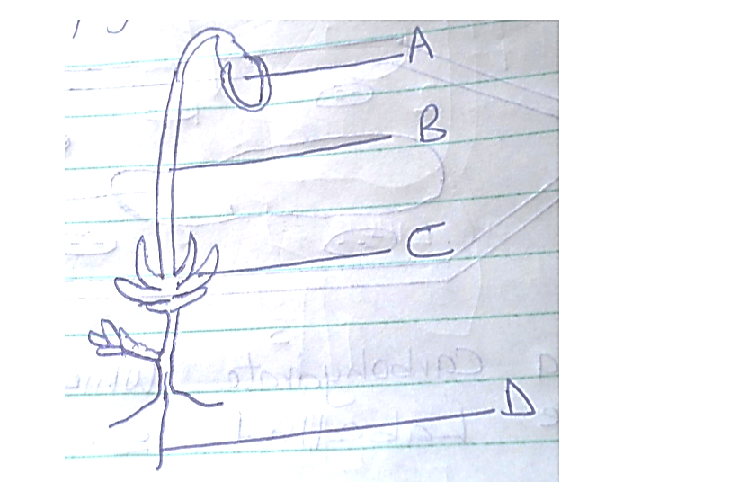

(i) Name the parts labeled B and D (2mks)

B -

D -

(ii) State one function for each of the parts labelled A and C (2mks)

A -

B -

(a). To which phylum and class does the following organism belong ?

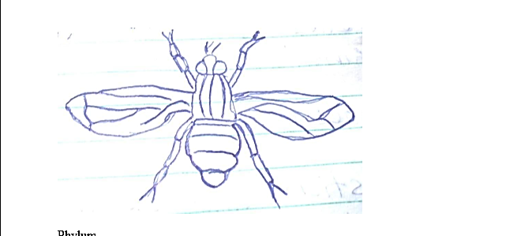

Phylum -

Class -

(b) Using observable features in the diagram, give two reasons for the phylum you have stated in

1. Distinguish between the following terms :-(2mks)

a) Magnification and resolution of a microscope ………………………………………………………………………………………………………………………………………………………………………………………………………………

1. The figure below shows a transverse section of a monocot stem. Study it and answer the questions that follow.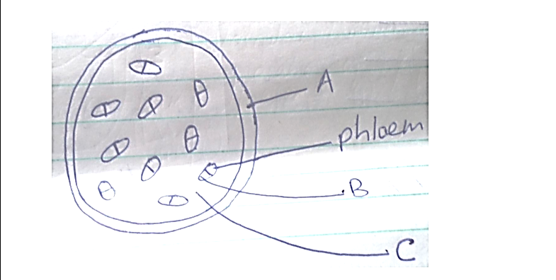

(a) Name the parts labeled A, B and C (3mks)

A -

B -

C -

(b) State the function of the part labelled C (2mks)

……………………………………………………………………………………………………

(c) State three differences between a monocot stem and a dicot stem. (3mks)

|  |  |
| --- | --- |
| Monocot stem | Dicot stem |
|  |  |
|  |  |
|  |  |

1. Explain the economic importance of the organisms of each of the following kingdoms.

(a) Monera (4mks)

……………………………………………………………………………………………………

……………………………………………………………………………………………………

……………………………………………………………………………………………………

……………………………………………………………………………………………………

(b) Fungi (4mks)

……………………………………………………………………………………………………

……………………………………………………………………………………………………

……………………………………………………………………………………………………

……………………………………………………………………………………………………

1. State two difference between monosaccharide and polysaccharides (2mks)

|  |  |
| --- | --- |
| Monosaccharides | Polysaccharide |
|  |  |
|  |  |

1. a) What is the formula for calculating linear magnification of a specimen when using a

hand lens (1mk)

……………………………………………………………………………………………………

……………………………………………………………………………………………………

1. The figure below illustrates a part of kidney nephron

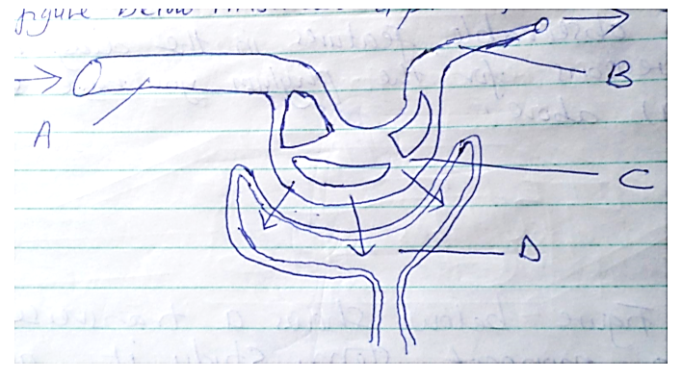

(a) Name the parts labeled A, B and D (3mks)

A -

B -

D -

(b) State one observable difference between part A and B (1mk)

……………………………………………………………………………………………………

(c) Name the fluid that is found in part D (1mk)

……………………………………………………………………………………………………

1. State three properties of the cell membrane (3mks)

……………………………………………………………………………………………………

SECTION B (40MKS)

1. An experiment was set up to investigate the effect of light on the rate of photosynthesis in the shoot of a water plant. The gas given off by the shoot was collected for 5 minutes at different light intensities and the volume measured. The results obtained are shown on the table below.

|  |  |
| --- | --- |
| Light intensity (units | Gas collected (cm3 / 5min) |
| 1 | 0.35 |
| 2 | 0.60 |
| 3 | 0.85 |
| 5 | 1.20 |
| 10 | 1.55 |
| 20 | 1.70 |
| 30 | 1.80 |
| 40 | 1.79 |
| 50 | 1.79 |

(a) Using the data given in the table, plot a graph of the volume of the gas collected against light intensity. (6mks)

(b) Account for the rate of gas production in the following intervals of light intensity.

(i) 1 - 10 (2mks)

……………………………………………………………………………………………………

……………………………………………………………………………………………………

(ii) 30 – 50 (2mks)

……………………………………………………………………………………………………

……………………………………………………………………………………………………

(c) Write a word equation for the process of photosynthesis (2mks)

……………………………………………………………………………………………………

(d) State the products of the light stage of photosynthesis (2mks)

……………………………………………………………………………………………………

……………………………………………………………………………………………………

(e) State the role of light in photosynthesis. (1mak)

……………………………………………………………………………………………………

(f) Other than light intensity, name two other factors that affect the rate of photosynthesis. (1mk)

……………………………………………………………………………………………………

1. Explain how abiotic factors (Environmental factors) affect plants. (20mks)

……………………………………………………………………………………………………

……………………………………………………………………………………………………

……………………………………………………………………………………………………

……………………………………………………………………………………………………

……………………………………………………………………………………………………

……………………………………………………………………………………………………

……………………………………………………………………………………………………

……………………………………………………………………………………………………

……………………………………………………………………………………………………

……………………………………………………………………………………………………

……………………………………………………………………………………………………

……………………………………………………………………………………………………

……………………………………………………………………………………………………

……………………………………………………………………………………………………

……………………………………………………………………………………………………

……………………………………………………………………………………………………

……………………………………………………………………………………………………

……………………………………………………………………………………………………

……………………………………………………………………………………………………

……………………………………………………………………………………………………

……………………………………………………………………………………………………

**MARKING SCHEME – FORM 3 BIOLOGY TERM II OPENER EXAMS**

**SECTION A (60 MARKS)**

**1. Respiratory Quotient (RQ)**

**a.**

* **Definition of RQ (1 mark):**  
  The ratio of the volume of carbon dioxide produced to the volume of oxygen consumed during respiration.

**a. (i) Calculation of RQ (1 mark):**

* Given equation:  
  �54�104�6+80�2→57��2+52�2�+38.21�*C*54​*H*104​*O*6​+80*O*2​→57*CO*2​+52*H*2​*O*+38.21*g*
* **RQ = Volume of CO₂ produced / Volume of O₂ consumed**  
  ��=5780=0.7125*RQ*=8057​=0.7125

**a. (ii) Type of food oxidized (1 mark + 1 mark for reason):**

* **Type:** Lipid (fat)
* **Reason:** The RQ is approximately 0.7, which is characteristic of lipids.

**2. Plant Cell Diagram**

**a.**

* **Carbohydrate in structure S (1 mark):** Cellulose

**b.**

* **Functions of part R (2 marks):**
  1. Controls cell activities (contains genetic material).
  2. Regulates cell division and growth.

**c.**

* **Structures absent in animal cells (2 marks):**
  1. Cell wall
  2. Chloroplasts

**ii.**

* **Organelles and their functions (3 marks):**
  + **(a) Excretion in amoeba:** Contractile vacuole
  + **(b) Digestion and destruction of worn-out organelles:** Lysosomes
  + **(c) Movement in paramecium:** Cilia

**3. Microscope Section Preparation (3 marks)**

**a.**

* **Making thin sections:** Allows light to pass through for clear viewing.

**b.**

* **Using a sharp blade:** Prevents cell damage and ensures clean cuts.

**c.**

* **Staining:** Enhances contrast for better visibility of cell structures.

**4. Organelle Functions (2 marks)**

* **(i) Lysosomes:** Contain digestive enzymes for breaking down waste.
* **(ii) Mitochondria:** Site of aerobic respiration (ATP production).

**5. Fish Population Study**

**a.**

* **Apparatus needed (2 marks):**
  1. Net
  2. Measuring tape/meter rule
  3. Tags/markers
  4. Notebook for recording

**b. (i)**

* **Sampling method (1 mark):** Capture-recapture method

**(iii)**

* **Precautions (2 marks):**
  1. Ensure marked fish are not harmed.
  2. Allow sufficient time for mixing before recapture.

**d. (i)**

* **Formula (3 marks):**  
  Total population=(First capture × Second capture)Marked recapturesTotal population=Marked recaptures(First capture × Second capture)​

**(i)**

* **Assumptions (2 marks):**
  1. No migration in/out of the pond.
  2. Marking does not affect survival.

**(d)**

* **Effect of light intensity (4 marks):**
  + Fish may avoid high light (predator risk).
  + Some species prefer shaded areas for feeding.

**6. Movement Across Cell Membrane (3 marks)**

1. Diffusion
2. Osmosis
3. Active transport

**7. Bryophyta Diagram**

**i.**

* **Parts B and D (2 marks):**
  + **B:** Capsule
  + **D:** Rhizoids

**ii.**

* **Functions (2 marks):**
  + **A:** Photosynthesis
  + **C:** Anchorage and absorption

**8. Magnification vs. Resolution (2 marks)**

* **Magnification:** Enlargement of an image.
* **Resolution:** Clarity of fine details.

**9. Monocot Stem**

**a.**

* **Parts A, B, C (3 marks):**
  + **A:** Epidermis
  + **B:** Vascular bundle
  + **C:** Ground tissue

**b.**

* **Function of C (2 marks):** Storage and support

**c.**

* **Differences (3 marks):**

| **Monocot Stem** | **Dicot Stem** |
| --- | --- |
| Scattered vascular bundles | Ring arrangement |
| No cambium | Has cambium |
| No secondary growth | Shows secondary growth |

**10. Economic Importance**

**a. Monera (4 marks):**

* Nitrogen fixation (e.g., Rhizobium).
* Decomposition (recycling nutrients).
* Used in fermentation (yogurt, antibiotics).
* Some cause diseases (e.g., tuberculosis).

**b. Fungi (4 marks):**

* Decomposers (recycle organic matter).
* Used in baking/brewing (yeast).
* Source of antibiotics (Penicillin).
* Some cause diseases (e.g., athlete’s foot).

**11. Monosaccharides vs. Polysaccharides (2 marks)**

| **Monosaccharides** | **Polysaccharides** |
| --- | --- |
| Simple sugars (e.g., glucose) | Complex (e.g., starch) |
| Soluble in water | Insoluble |

**12. Linear Magnification Formula (1 mark)**

* Magnification=Image sizeActual sizeMagnification=Actual sizeImage size​

**13. Kidney Nephron**

**a.**

* **Parts (3 marks):**
  + **A:** Glomerulus
  + **B:** Bowman’s capsule
  + **D:** Collecting duct

**b.**

* **Difference (1 mark):**
  + **A** is a network of capillaries, while **B** is a cup-shaped structure.

**c.**

* **Fluid in D (1 mark):** Urine

**14. Cell Membrane Properties (3 marks)**

1. Selectively permeable.
2. Fluid mosaic structure.
3. Contains proteins for transport.

**SECTION B (40 MARKS)**

**15. Photosynthesis Experiment**

**a.**

* **Graph (6 marks):**
  + Correct axes labeling (Light intensity vs. Gas volume).
  + Accurate plotting of points.
  + Smooth curve showing plateau.

**b.**

* **(i) 1-10 units (2 marks):**
  + Rate increases with light (more energy for photosynthesis).
* **(ii) 30-50 units (2 marks):**
  + Rate plateaus (another factor becomes limiting, e.g., CO₂).

**c.**

* **Word equation (2 marks):**  
  Carbon dioxide + Water→LightGlucose + OxygenCarbon dioxide + WaterLight​Glucose + Oxygen

**d.**

* **Light stage products (2 marks):**
  + ATP
  + NADPH

**e.**

* **Role of light (1 mark):** Provides energy to split water (photolysis).

**f.**

* **Other factors (1 mark):**
  + Temperature
  + Carbon dioxide concentration

**16. Abiotic Factors Affecting Plants (20 marks)**

* **Light:** Affects photosynthesis rate.
* **Temperature:** Influences enzyme activity.
* **Water:** Essential for turgor and reactions.
* **Soil pH:** Affects nutrient availability.
* **Wind:** Increases transpiration.
* **Humidity:** Affects water loss.